DFO Rock Crab Trap Survey

The GNSFPB has been asked to assist DFO with their 2021 rock crab survey. PEI and Gulf NB are also helping. The harvesters in the following Harbours of Finlay Point, NS, Mabou Harbour, NS, or Murphy’s Pond, NS will be given priority due to their adjacency to the sampling area. The following is the project description.

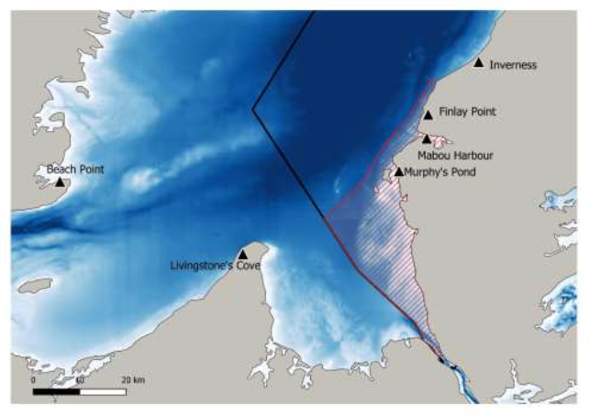
Figure 1 Photo of Rock Crab Survey sampling area for 26B.

Work Requirements
- Complete up to four days (August 3 – 6) of rock crab trap fishing at up to 30 pre-determined sampling stations, over a four-day period. A maximum of 30 sampling stations will be predetermined and presented to the Contractor prior to the survey by the Department of Fisheries and Oceans (DFO). The number of fishing days will be weather dependent and determined by the chief scientist in consultation with the captain.
- On the first day of work, deploy one scientific rock crab trap, rope and buoys at each predetermined station according to the rock crab trap survey protocol.
- On up to three subsequent days of work, retrieve, empty and re-deploy the traps in the same location.
- On the last day of work, retrieve and empty the traps.
- The traps will be the same size as standard commercial rock crab traps but will have a smaller mesh and no escape. The traps will be provided by DFO.
- At-sea activities include trap-fishing, biological measurements of captured rock crab of all sizes and of by-catch species (sorting, counting and total weight of by-catch species or species group).
- Personnel (one captain and at least two (2) crew members) must be qualified and experienced at deploying and retrieving commercial fishing traps (i.e. lobster, rock crab or snow crab) and must assist DFO scientific representatives. At least one (1) member of the crew must be available to assist the DFO representatives when measuring crab and when collecting biological and physical data for the entire duration of the survey.
- The scientific authority from DFO on board can collect and conserve rock crabs, as well as other marine species, for biological studies.

DFO Obligations
- DFO chief scientist will provide and deliver to the vessel all required fishing gear including traps, rope and buoys, materials and electronics required.

Contractor Obligations
Vessel Requirements
- The contractor shall ensure that the vessel is seaworthy, the main engine, equipment and fishing gear, are in good operating condition. The vessel must have sufficient room for the work planned and be equipped with adequate mechanical and electronic navigation equipment as well as the survival equipment set out in the Canada Shipping Act.
- Maintain, throughout the contract period, all certificates, lifesaving equipment and apparatus as required by The Canada Shipping Act and pursuant regulations.
- The vessel will provide fuel for trips.
- The vessel and crew will be ready on twenty four (24) hours’ notice within the contract period.
- Bait of 5lb of frozen herring per day per trap for 24 traps is required and to be supplied by the vessel Master.

Master and Crew Requirements
- A captain and at least two (2) qualified and experienced crew members will be required during the entire study who are able to assist DFO scientific personnel during sampling and data collection. DFO representatives should not be included when determining crew requirements.
- The crew and captain will be able to repair traps on board the vessel and at the wharf (repair materials will be provided by DFO). These crew members must be available for the entire survey.

Additional Requirements
- Although the captain is in charge at all times, he/she shall comply with the instructions of DFO scientific authority provided the safety of the vessel and the crew members is not compromised.
- The captain and crew members must provide a healthy work environment, smoke free (inside the vessel) and respectful. Any physical, verbal or psychological harassment from the captain, crew members or contractor will not be tolerated.
- The captain of the vessel must keep a daily log of operations and activities on board the vessel, both at sea and in port, and shall allow access to the log by the DFO scientific authority at all times.
- The captain shall provide all possible cooperation and assistance to the DFO scientific authority with regards to the gathering, preparation and updating of documents concerning the specific sites sampled and the species and quantities of fish and invertebrates caught.
- No commercial fishing activities shall be conducted during the period set aside for the study. The captain may not take advantage of the research survey to do any commercial fishing.

Any catches become the exclusive property of DFO for research purposes. Neither the captain, crew nor DFO representatives may keep or consume any part of the catch.

Work can be carried out in French speaking or English speaking environment, as suits the contractor.

Work will be performed under a Section 52 Science fishing license accompanied by a Gulf Region Fisheries Research Notice maintained by the chief scientist on behalf of DFO. A copy of the license will be given to the captain by the chief scientist and must be kept onboard for the duration of the contract.

All DFO staff and vessel crew will comply with the provincial COVID-19 safety guidelines and regulations in place in the province where the berthing port is located.

The successful applicant will be paid by GNSFPB upon completion of the project. Compensation would be $2500 per day sampled and $500 standby rate if weather prevents sampling trip.

Deadline of application is Wednesday July 21st 2021. Any harvesters interested, please contact:

Stephanie Delorey
Science & Communications Coordinator
Gulf Nova Scotia Fleet Planning Board
scc.gnsfpb@gmail.com
902-968-1109

